Using Genetic Algorithms to Optimize the Analogue Method for Precipitation

Forecasting in the Swiss Alps

The analogue method is often used to forecast precipitation based on predictors variables provided by global models. The method samples a selection of days in the archives that are similar to the target day to forecast, and consider the set of their corresponding observed precipitation (the predictand) as the conditional distribution for the target day. The relationship between predictors and predictands relies on some parameters that characterize how and where the similitude between two atmospheric situations is defined.

This relationship is usually established by a semi-automatic sequential procedure that has strong limitations. A new global optimization approach relying on Genetic Algorithms can optimize all parameters jointly and automatically, which is a breakthrough in the way the analogue method was calibrated until now. It allows taking into account parameters inter-dependencies, adding new degrees of freedom, and choosing objectively some parameters that were manually selected beforehand (such as the pressure levels and the temporal windows of the predictor variables).

In this work, the global optimization is applied to the Rhône catchment in the Swiss Alps in order to show its interest and the relevance of the resulting parameters. Indeed, not only the performance increases, but the parameters are obtained automatically and objectively, which reduces the computer burden when adapting the method to a new region or for a new predictand. Moreover, the approach allows for new degrees of freedom, such as a weighting between the pressure levels and non overlapping spatial windows.

Precipitation forecast and downscaling Analogue method Optimization Genetic algorithms Alpine climate

## 1 Introduction

The analogue method (AM) is a downscaling technique based on the idea expressed by [14, 15], that similar situations in terms of atmospheric circulation are likely to lead to similar local weather [6, 4]. It aims at forecasting a predictand, often the daily precipitation [?, eg.]]Guilbaud1997, Bontron2005, Bliefernicht2010, Marty2012, Horton2012, Radanovics2013, BenDaoud2015, on the basis of predictor variables describing the synoptic atmospheric circulation. Other predictands are also often considered [?, see]for a non-exhaustive list]Horton2016.

In operational forecasting, it has been used mainly by practitioners, notably hydropower companies or flood forecasting services, while in climate studies, it is used to downscale the results of global climate model (GCM) simulation runs. In this last case, although the GCM represents the large or regional scale evolutions of the atmosphere, it would be far too computer intensive to get down to variables such as precipitation at a rather small and representative scale. Therefore the idea is to rely on past observations to bypass these unaffordable small scale simulations and to go from the large scale situation proposed by the GCM to the end variables like precipitation by searching analogues in the archives.

The method can be made of multiple successive subsampling steps, each of them relying on different meteorological variables. A certain number of parameters define the relationship between predictors and predictands, such as the choice of the predictor variable, its pressure level and temporal window to consider, the spatial domain to use for the comparison, as well as the analogy criteria itself, and finally the number of analogue situations to keep at each subsampling level. These parameters are usually calibrated by means of a semi-automatic sequential procedure [?, see]for the details]Bontron2004, Horton2016 ,i.e. by optimizing each single parameterone at a time in an arbitrarily chosen orderwith no or little reconsidering. This sequential approach has therefore strong limitations: (i) it cannot automatically choose the pressure levels and the temporal windows for a given meteorological variable, (ii) it cannot handle dependencies between the parameters within a level of analogy, and even less between them, and (iii) it could not easily handle new degrees of freedom, such as a weighting between the pressure levels. Thus, even if the processing involved is relatively fast, the sequential approach requires laborious assessments of predictors combinations (variables, pressure levels, temporal windows), and present a high risk of ending in a local optimum due to subjective initial choices and lack of consideration of parameters inter-dependencies.

With the perspective to overcome these limitations, a global optimization by Genetic Algorithms (GAs) was introduced by [12]. An intensive assessment work resulted in recommendations of parametrization of GAs in order to optimize AMs successfully. The present paper is based on these recommendations and illustrate them on precipitation forecasting for the upper Rhône catchment in the Swiss Alps. It aims at proving the relevance of a fully-automatic, objective, and global, optimization technique for AMs. The applications are indeed numerous, as the AM has to be adapted to every new location it is applied, or to any new predictand it should forecast.

A short overview of AMs is presented in section 2, as well as a summary of Genetic Algorithms in section 3. Section 4 describes the case study area. The results are first detailed for the optimization of the analogy on the atmospheric circulation only (section 5), before being extended to a method adding a second level of analogy on moisture variables (section 6). General discussions (section 7) and conclusions (section 8) follow.

## 2 The analogue method

### 2.1 References

Multiple variations of the methods exist, and most of them will not be detailed hereafter [?, see]for more comprehensive listings]Horton2016, BenDaoud2015. However, there are mainly 2 parameterizations that are most often used for precipitation forecasting and that will be considered as reference: one that relies on an analogy of the atmospheric circulation, and another that adds a second level of analogy on moisture variables [18, 4, 16].

The method based on the analogy of the synoptic circulation consists in the following steps (Table 1): the similarity of the atmospheric circulation of a target date with every day of the archive is assessed by processing the S1 criteria [?, Eq.:S1,]]Teweles1954, Drosdowsky2003, which is a comparison of gradients, over a certain spatial window. [4] showed that the geopotential height at 500 hPa (Z500) and 1000 hPa (Z1000) are the best first predictors of the NCEP/NCAR reanalysis dataset, and that the S1 criteria performs better than scores based on absolute distances. The reason for such better results is that the S1 criteria allows comparing the circulation pattern, by means of the gradients, rather than the absolute value of the geopotential height. To cope with seasonal effects, candidate dates are extracted within a period of 4 months centered around the target date, for every year of the archive. Following the nomenclature proposed by [11], this method using two geopotential heights will be named 2Z.

 (1)

where  is the forecast geopotential height difference between the *i*th pair of adjacent points of the gridded data describing the target situation, and  is the corresponding observed geopotential height difference in the candidate situation. The differences are processed separately in both directions over the selected spatial domain. The smaller the S1 values, the more similar the pressure fields.

Table 1: Parameters of the reference method on the atmospheric circulation (2Z). The first column is the level of analogy (0 for preselection), then comes the meteorological variable and its hour of observation (temporal window). The criteria used for the current level of analogy is then provided, as well as the number of analogues.

|  |  |  |  |  |
| --- | --- | --- | --- | --- |
| Level | Variable | Hour | Criteria | Nb |
|  | days around the target date | | | |
| *1 | Z1000 | 12 h | 2*S1 | 2*50 |
|  | Z500 | 24 h |  |  |

The  dates with the lowest values of S1 are considered as analogues to the target day. The number of analogues, , is a parameter to calibrate. Then, the daily observed precipitation amount of the  resulting dates provide the empirical conditional distribution considered as the probabilistic forecast for the target day.

The other most know parametrization adds a second level of analogy on moisture variables (method 2Z-2MI, Table 2). The predictor that [5] found optimal for the France territory is a moisture index made of the product of the precipitable water with the relative humidity at 850 hPa (RH850). [13] confirmed that this index is also better for the Swiss Alps than any other variable from the NCEP/NCAR reanalysis considered independently. When adding a second level of analogy,  dates are subsampled in the  analogues on the atmospheric circulation, to end up with a smaller number of analogue situations. When a second level of analogy is added, a higher number of analogues N1is kept on the first level.

Table 2: Parameters of the reference method with moisture variables (2Z-2MI). Same conventions as Table 1

|  |  |  |  |  |
| --- | --- | --- | --- | --- |
| Level | Variable | Hour | Criteria | Nb |
|  | days around the target date | | | |
| *1 | Z1000 | 12 h | 2*S1 | 2*70 |
|  | Z500 | 24 h |  |  |
| *2 | TPW * RH850 | 12 h | 2*RMSE | 2*30 |
|  | TPW * RH850 | 24 h |  |  |

### 2.2 Data

The AM relies on two types of data: predictors, that are atmospheric variables describing the state of the atmosphere at a synoptic scale, and the predictand, which is the local weather time series one wants to forecast.

Predictors are generally reanalysis datasets. NCEP-NCAR reanalysis [?, 6-hourly, 17 pressure levels at a resolution of 2.5, see]]Kalnay1996 are used here, but it could be any other reanalysis dataset.

The predictand (which is to be predicted) is here the daily precipitation (6 a.m. to 6 a.m. the next day) measured at the MeteoSwiss' stations network, for the period 1961-2008. The time series from every available gauging station were averaged over subregions of ~500 km² in order to smooth local effects [18, 16].

### 2.3 Performance assessment

The score that is most often used to assess an AM performance is the CRPS [?, Continuous Ranked Probability Score,]]Brown1974, Matheson1976, Hersbach2000. It allows evaluating the predicted cumulative distribution functions , for example of the precipitation values  from analogue situations, compared to the observed value . The better the forecast, the smaller the score. The mean CRPS of a forecast series of length  can be written:

 (2)

where  is the Heaviside function that is null when , and has the value 1 otherwise. The mean CRPS is averaged on the calibration, respectively the validation periods, on all days.

In order to compare the value of the score in regard to a reference, one often considers its skill score expression, and use the climatological distribution of daily precipitation as the reference. The CRPSS (*Continuous Ranked Probability Skill Score*) is thus defined as following:

 (3)

where  is the CRPS value for the reference and  would be the one for a perfect forecast (which implies ). A better forecast is characterized by an increase in CRPSS.

## 3 Genetic algorithms

Genetic Algorithms (GAs) were developed by [9] and popularized by [8]. They are part of Evolutionary Algorithms [1, 19], which get inspiration from some mechanisms of biological evolution, such as reproduction, genetic mutations, chromosomal crossovers, and natural selection. GAs seek the global optimum on a complex surface, theoretically without restriction. Practically, GAs allow rapidly approaching satisfactory solutions, but they do not provide the optimum solution for sure [20]. It is indeed mainly a matter of time. When the optimizer gets closer to the global optimum, any new improvement takes more time to appear (see for example Figure 10), and the final adjustment of the parameters is very time consuming [2]. For problems that require a significant amount of time in order to evaluate the objective function, as in the case of AMs, the number of generations has to be limited in order to get reasonable processing time. Thus, different acceptable solutions can result from one or more optimizations [9]. This is a strength and a weakness of GAs: they are very good at exploring complex parameter spaces in order to identify the most promising areas, but they will not necessarily always find the best solution with the optimal values of all parameters [9].

The optimizations were performed based on the recommended GAs parametrization for AMs as described in [12]. As the optimization is mostly sensitive to the mutation operator (that randomly changes some values in the parameters sets), parallel optimizations are considered with variants of this operator, according to [12]:

• 3x non-uniform mutation [17] with varying parameters,

• 1x multi-scale mutation [12],

• 2x chromosome of adaptive search radius [12]

A population size of 500 individuals (parameter sets of the AM-to be detailed hereunder) was considered, and the optimization was stopped when the best individual (with the highest CRPSS performance score) did not evolve for 20 generations (cycles of the optimization).

## 4 Case study description

The study area is the alpine upper Rhône catchment in Switzerland (Fig. 1). The altitude ranges from 372 to 4634 m.a.s.l. and the area is 5524 km. This region is the target of the MINERVE (Modélisation des Intempéries de Nature Extrême sur les Rivières Valaisannes et de leurs Effets) project that aims at a real-time flood management on the upper Rhône catchment [7]. Even though the region is rather small, the meteorological influences related to extreme weather conditions varies substantially within it [?, see]]Horton2012. Based on different climatological analyses, the gauging stations in the catchment were clustered in 10 subregions (Fig. 1) :

1. Swiss Chablais

2. Trient Valley

3. West Bernese Alps

4. Lower Rhone Valley

5. Left side valleys

6. Southern ridges

7. Upper Rhone Valley

8. Southeast ridges

9. East Bernese Alps

10. Conches Valley

The 48 years precipitation dataset (see section 1.2.2) was divided into a calibration period (CP) and a validation period (VP). Using data independent from the CP to validate the results is very important in order to assess the robustness of the improvements and to avoid over-parametrization of the method.

In order to reduce potential bias related to trends linked to climate change or to the evolution in measurement techniques, the selection of the VP is evenly distributed over the entire series [3]. Thus, one year every six years were selected for validation, which represents a total of 8 years for the VP and 40 for CP. The choice of the sequence was made in order to have similar statistical characteristics between the CP and the VP.

## 5 Optimization of the circulation analogy

The analogy of the atmospheric circulation was optimized for the 10 subregions independantly. We started from the most simple AM, and increased the complexity in order to identify the degrees of freedom that are of particular interest. Thus, the tested parametrization evolved iteratively in complexity. The detailed results of the intermediate stages are not provided [?, see]for the details]Horton2012a.

The reference method for the analogy of the atmospheric circulation (2Z, Table 1), based on the 500 and 1000 hPa levels, was first considered. The optimizer had to choose the number of analogues, both spatial windows with no overlapping constraint, as well as the temporal windows (hours of observation of the geopotential), what the sequential calibration cannot do. With these degrees of freedom, a relative CRPSS improvement of 3.97% and 2.45% in average was obtained for the CP and the VP respectively. Some tests showed that most of the gains are due to the non-overlapping spatial windows. This is not a tremendous improvement, but it demonstrated that the optimizer was able to get relevant parameters.

Then, an additional degree of freedom was provided to the GAs by letting them choose the pressure levels along with the other parameters, which is also a non-automated process in the sequential calibration. This degree of freedom increased the optimization time and may decrease the number of simulations that converge to a single solution. However, most solutions were very close in terms of score. The averaged relative improvement of the CRPSS is 5.63% for the CP and 3.82% for the VP. The pressure levels that were chosen are 500 hPa or 700 hPa for the upper level, and 925 hPa or 1000 hPa (most often) for the lower level.

Parallel analyses showed that the analogy of circulation is incomplete, and that the geopotential still contains relevant information that can improve the statistical relationship. Therefore, a third predictor was added (still on the geopotential height) that the optimizer could use along with the previous parameters. There was no constraint on the predictors, so that the same pressure level could be selected more than once. Some improvements were found on the score, both for the CP and the VP, confirming that this additional information is beneficial for the quality of the forecast. We then tried with 4 predictors, and so on, up to 8. Every time a new predictor to optimize was added, the score on the CP increased, but always more to a smaller extent. However, the score value on the VP dropped after 4 predictors, revealing an over-parametrization of the method, and thus a lack of robustness. Considering 4 predictors is optimal for this case study, since the gain in CRPSS is significant. It cannot be excluded that another number would prevail in another region under other meteorological conditions.

Finally, a weighting of the criteria values per pressure level was proposed, again optimized by GAs. The weighting operates in the combination of the S1 criteria processed on every level, which were previously averaged with equal weights. The role of this new degree of freedom is to give more weight to the levels with greater predictive capacity, and to consider the geopotential variability changes with altitude.

### 5.1 Which parameters are optimized ?

The chosen method for the atmospheric circulation analogy, based on 4 levels of the geopotential, and that will be name 4Zo, is made of the following degrees of freedom:

• the selection of the pressure levels (4 degrees)

• the temporal windows (4 degrees)

• the spatial windows (4x4 degrees)

• the weights (4 degrees)

• the number of analogues (1 degree).

This sums up to 29 degrees of freedom that are optimized simultaneously.

### 5.2 Results for the 4Zo method

The resulting optimized parameters for 4Zo vary from one subregion to another. An example of the detailed parameters is provided for the Swiss Chablais in Table 3. The optimized spatial windows are given for every subregion in Figure 2, and the selected pressure levels in Table 4.

Table 3: Parameters of the 4Zo method (analogy on 4 levels of the atmospheric circulation) optimized for the Chablais subregion. The columns are the following: L = level of analogy, V = meteorological variable, H = hour of observation or temporal window, D = domain or spatial window, W = weighting of the score for the selected pressure levels, C = criteria, N = number of analogues.

|  |  |  |  |  |  |  |
| --- | --- | --- | --- | --- | --- | --- |
| L | V | H | D | W | C | N |
|  | days around the target date | | | | | |
| *1 | 2*Z300 | 2*12 h | -2.5 - 15.0 E | 2*32% | 8*S1 | 8*28 |
|  |  |  | 37.5 - 57.5 N |  |  |  |
|  | 2*Z700 | 2*24 h | 2.5 - 10.0 E | 2*22% |  |  |
|  |  |  | 42.5 - 45.0 N |  |  |  |
|  | 2*Z1000 | 2*6 h | -5.0 - 15.0 E | 2*24% |  |  |
|  |  |  | 42.5 - 47.5 N |  |  |  |
|  | 2*Z1000 | 2*30 h | 2.5 - 15.0 E | 2*22% |  |  |
|  |  |  | 40.0 - 50.0 N |  |  |  |

Table 4: Pressure levels () automatically selected for the 4Zo method at the different subregions.

|  |  |  |  |  |  |  |  |  |
| --- | --- | --- | --- | --- | --- | --- | --- | --- |
| ID | 300 | 400 | 500 | 600 | 700 | 850 | 925 | 1000 |
|  |  |  |  |  |  |  |  |  |
|  |  |  |  |  |  |  |  |  |
|  |  |  |  |  |  |  |  |  |
|  |  |  |  |  |  |  |  |  |
|  |  |  |  |  |  |  |  |  |
|  |  |  |  |  |  |  |  |  |
|  |  |  |  |  |  |  |  |  |
|  |  |  |  |  |  |  |  |  |
|  |  |  |  |  |  |  |  |  |
|  |  |  |  |  |  |  |  |  |

Table 5: CRPSS score (%) of the three optimized methods (4Zo is the atmospheric circulation analogy detailed in the present section; 4Zo-2MIo and 4Zo-4MIo add a second level of analogy on moisture indexes, as explained in section 6).

|  |  |  |  |  |  |  |
| --- | --- | --- | --- | --- | --- | --- |
| ID | 4Zo | | 4Zo-2MIo | | 4Zo-4MIo | |
|  | CP | VP | CP | VP | CP | VP |
|  | 40.3 | 38.5 | 45.5 | 43.8 | 45.9 | 43.6 |
|  | 37.8 | 34.9 | 42.4 | 40.8 | 42.9 | 41.3 |
|  | 36.6 | 33.9 | 41.4 | 39.0 | 41.8 | 39.5 |
|  | 31.2 | 30.8 | 36.1 | 36.4 | 36.8 | 37.1 |
|  | 34.4 | 36.5 | 38.6 | 41.4 | 39.2 | 41.8 |
|  | 37.0 | 39.9 | 41.0 | 44.5 | 41.9 | 44.6 |
|  | 30.0 | 30.1 | 33.8 | 34.6 | 34.4 | 34.8 |
|  | 37.7 | 40.1 | 40.7 | 43.1 | 41.2 | 43.3 |
|  | 33.1 | 30.0 | 38.4 | 36.6 | 38.7 | 36.3 |
|  | 40.0 | 40.0 | 42.6 | 42.9 | 43.3 | 43.2 |
| av. | 35.8 | 35.5 | 40.1 | 40.3 | 40.6 | 40.5 |

Table 6: Same as Table 5, but expressed as the CRPSS improvement (%) compared to the reference methods. For 4Zo, the improvement is relative to the reference method on the atmospheric circulation (2Z, Table 1). For 4Zo-2MIo and 4Zo-4MIo, the improvement is relative to the reference method on the circulation and moisture variables (2Z-2MI, Table 2).

|  |  |  |  |  |  |  |
| --- | --- | --- | --- | --- | --- | --- |
| ID | 4Zo | | 4Zo-2MIo | | 4Zo-4MIo | |
|  | CP | VP | CP | VP | CP | VP |
|  | 13.6 | 13.0 | 11.9 | 9.9 | 12.8 | 9.6 |
|  | 13.3 | 7.5 | 11.2 | 9.4 | 12.5 | 10.8 |
|  | 12.2 | 9.0 | 13.2 | 12.0 | 14.1 | 13.5 |
|  | 14.2 | 10.5 | 12.4 | 10.6 | 14.5 | 12.5 |
|  | 14.5 | 8.8 | 12.5 | 9.1 | 14.1 | 10.0 |
|  | 13.3 | 8.6 | 11.5 | 8.2 | 14.1 | 8.4 |
|  | 22.8 | 10.6 | 19.7 | 15.7 | 21.7 | 16.3 |
|  | 20.7 | 11.9 | 19.2 | 13.5 | 20.8 | 14.0 |
|  | 14.4 | 9.5 | 15.8 | 15.2 | 16.7 | 14.1 |
|  | 14.2 | 9.4 | 12.9 | 11.2 | 14.6 | 11.8 |
| av. | 15.3 | 9.9 | 14.0 | 11.5 | 15.6 | 12.1 |

Table 7: Improvement (%) of the CRPSS for different precipitations thresholds for the optimized 4Zo method.

|  |  |  |  |  |  |  |
| --- | --- | --- | --- | --- | --- | --- |
| ID | P1 mm | | P0.1P10 | | P0.5P10 | |
|  | CP | VP | CP | VP | CP | VP |
|  | 10.2 | 9.4 | 8.5 | 7.9 | 17.0 | 14.2 |
|  | 9.9 | 3.4 | 10.2 | 7.3 | 19.3 | 13.7 |
|  | 13.3 | 10.5 | 13.3 | 10.9 | 19.7 | 9.7 |
|  | 11.0 | 7.4 | 12.9 | 10.0 | 23.2 | 23.8 |
|  | 8.6 | 4.2 | 10.9 | 6.2 | 25.2 | 23.8 |
|  | 10.5 | 5.1 | 11.1 | 7.1 | 21.2 | 41.1 |
|  | 24.3 | 12.4 | 33.1 | 26.0 | 71.2 | 104.3 |
|  | 19.0 | 12.7 | 26.2 | 19.2 | 39.4 | 34.9 |
|  | 12.4 | 6.8 | 13.8 | 9.9 | 24.9 | 48.1 |
|  | 13.6 | 6.8 | 14.4 | 6.9 | 29.9 | 31.5 |
| av. | 13.3 | 7.9 | 15.4 | 11.1 | 29.1 | 34.5 |

The resulting CRPSS scores are provided in Table 5 and are in average 35.8 % for the CP and 35.5 % for the VP. The improvement of the CRPSS score relatively to the reference method on the atmospheric circulation is provided in Table 6 and is in average 15.3 % for the CP and 9.9 % for the VP. The score was also calculated for three precipitation thresholds: P1 mm, P0.1P10 and P0.5P10, P10 being the daily precipitation with a 10 year return period (Table 7). The gain in score increases with the precipitation threshold: in average, respectively for the different thresholds, 13.3%, 15.4% and 29.1% for the CP and 7.9%, 11.1% and 34.5% for the VP. The optimization improves thus even more the forecasts for days with significant precipitation than usual days.

To assess the parameters cross-compatibility, those optimized for one subregion were applied to the others. The resulting losses or gains of the CRPSS are displayed in Figure 3 for the CP and in Figure 4 for the VP.

### 5.3 Analysis

The automatic selections of the pressure levels (Table 4) and the temporal windows (not shown) for the analogy of circulation show a great homogeneity and are spatially consistent. First of all, the level 1000 hPa is always selected twice (the first time at 6 or 12 h, and the second always at 30 h) and the 700 hPa is selected once for every subregion (always at 24 h). The level which varies from one subregion to another is the upper level (however always at 12 h), which is 300 hPa for the North-West part of the catchment, 500 hPa for most of the subregions, and 600 hPa for the Conches Valley. Its spatial distribution is however homogeneous. The optimizer thus provided consistent selections of pressure levels and temporal windows, which depicts a significant preference in the AM, and the success of GAs to provide consistent results. The automatic selection of the pressure levels is a big advantage in favor of a global optimization, as it is not possible to assess all combinations of 4 levels with the sequential calibration procedure.

The resulting spatial windows (Figure 2) may look very diverse first, but there are significant similarities for subregions located within the same vicinity. The first 4 subregions are characterized by a large spatial window on the upper level, whereas it becomes smaller for the other subregions. For most subregions, the second level (700 hPa) is represented by thin and longitudinally extended domains. The third level (1000 hPa at 6 or 12 h) also contains longitudinally extended domains, but a bit larger. The last one (1000 hPa at 30 h) is rather large and squared. Subregions number 5 (Left side valleys) and 6 (Southern ridges) have exactly the same spatial windows, which suggest that they behave in a similar way and thus could have been merged. This similarity is a good sign for the accuracy of the optimized parameters.

The scores show significant improvements for both the CP and the VP (Table 6). Even more interestingly, the results for higher precipitation thresholds (Table 7) show the largest improvements. This is of particular interest in the framework of flood forecasting.

The analysis of the parameters cross-compatibility shows that obviously, the parameters are optimal on the CP when they are calibrated for the given subregion (Figure 3). However, the losses in CRPSS when exchanging the parameters are not of the same magnitude between the different subregions. Indeed, the Upper Rhone Valley (7) and moreover the Southeast ridges (8) seem to behave significantly differently. This is indeed a climatological reality, as this subregion is the most sensitive to southerly flows [10]. Parameter sets from other subregions perform poorly for these subregions, and vice versa. This points at the importance of taking into account leading meteorological influences during discretization, that are not always best represented by the physical distance. Globally, the same pattern can be observed for the VP (Figure 4), but in this case, minor improvements may be observed when crossing the parameters. The reason being that the independent VP contains other events that may be better forecasted by other parameter sets. The relatively small differences in score between parameterizations indicate that even though the parameters may differ significantly, the performance may not be drastically affected. Even a change in the pressure level does not mean a radical drop of the score value. A different parametrization may lead to a different selection of the analogue days, and thus to an improvement of the forecast under certain weather conditions at the expense of others. This raises the question of optimizing more specifically for extreme weather conditions in priority.

## 6 Optimization of the analogy with moisture information

It is known that moisture variables as a second level of analogy do provide improvements to the method (section 2). The moisture index, which is a combination of the relative humidity and the precipitable water, has thus also to be optimized. In order to do so, a constraint to the optimizer had to be introduced, so as to select the same temporal window (time of observation) for both variables.

Two methods were assessed: one with 2 moisture predictors (moisture index on 2 pressure levels or at 2 different hours) named 4Zo-2MIo, and one with 4 moisture predictors named 4Zo-4MIo. When introducing 2 predictors for the moisture analogy, the number of degrees of freedom raises to 42, and to 54 with 4 predictors.

The optimization was processed on both levels of analogy simultaneously. This implies that the analogy of the atmospheric circulation may change due to the new moisture information.

### 6.1 Results for 4Zo-2MIo and 4Zo-4MIo methods

Due to significant similarities between the results from 4Zo-2MIo and 4Zo-4MIo, the latter will only be partly shown in order to improve readability.

As previously, the optimized parameters differ from one subregion to another, and this even to a greater extent. Detailed examples are again provided for the Swiss Chablais subregion in Table 8 for 4Zo-2MIo. The resulting spatial windows are displayed in Figure 5 for 4Zo-2MIo, along with the selected pressure levels for both the circulation and the moisture analogy (Table 9).

Table 8: Parameters of the 4Zo-2MIo method (atmospheric circulation on 4 levels and moisture index on 2 levels), optimized for the Chablais subregion. Same conventions as Table 3.

|  |  |  |  |  |  |  |
| --- | --- | --- | --- | --- | --- | --- |
| L | V | H | D | W | C | N |
|  | days around the target date | | | | | |
| *1 | 2*Z300 | 2*12 h | 0.0 - 15.0 E | 2*23% | 8*S1 | 8*74 |
|  |  |  | 42.5 - 55.0 N |  |  |  |
|  | 2*Z500 | 2*30 h | 0.0 - 10.0 E | 2*25% |  |  |
|  |  |  | 40.0 - 45.0 N |  |  |  |
|  | 2*Z850 | 2*12 h | 0.0 - 10.0 E | 2*26% |  |  |
|  |  |  | 42.5 - 47.5 N |  |  |  |
|  | 2*Z1000 | 2*30 h | 0.0 - 20.0 E | 2*26% |  |  |
|  |  |  | 40.0 - 47.5 N |  |  |  |
| *2 | TPW | 2*12 h | 5.0 - 10.0 E | 2*57% | 4*RMSE | 4*25 |
|  | *RH700 |  | 45.0 - 47.5 N |  |  |  |
|  | TPW | 2*24 h | 5.0 - 10.0 E | 2*43% |  |  |
|  | *RH700 |  | 45.0 - 47.5 N |  |  |  |

Table 9: Atmospheric levels automatically selected for the analogy of the atmospheric circulation () and the analogy of moisture () of the 4Zo-2MIo method, at the different subregions.

|  |  |  |  |  |  |  |  |  |
| --- | --- | --- | --- | --- | --- | --- | --- | --- |
| ID | 300 | 400 | 500 | 600 | 700 | 850 | 925 | 1000 |
|  |  |  |  |  |  |  |  |  |
|  |  |  |  |  |  |  |  |  |
|  |  |  |  |  |  |  |  |  |
|  |  |  |  |  |  |  |  |  |
|  |  |  |  |  |  |  |  |  |
|  |  |  |  |  |  |  |  |  |
|  |  |  |  |  |  |  |  |  |
|  |  |  |  |  |  |  |  |  |
|  |  |  |  |  |  |  |  |  |
|  |  |  |  |  |  |  |  |  |

Table 10: Improvement (%) of the CRPSS for different precipitations thresholds for the optimized 4Zo-2MIo method.

|  |  |  |  |  |  |  |
| --- | --- | --- | --- | --- | --- | --- |
| ID | P1 mm | | P0.1P10 | | P0.5P10 | |
|  | CP | VP | CP | VP | CP | VP |
|  | 12.6 | 9.3 | 12.4 | 9.7 | 15.8 | 11.0 |
|  | 10.4 | 7.7 | 11.2 | 10.5 | 18.9 | 16.6 |
|  | 14.5 | 11.6 | 14.1 | 11.4 | 18.7 | 14.6 |
|  | 11.4 | 9.4 | 11.5 | 11.6 | 14.9 | 22.7 |
|  | 11.8 | 8.0 | 12.2 | 8.9 | 12.0 | 12.8 |
|  | 11.3 | 7.1 | 11.2 | 8.0 | 15.3 | 29.1 |
|  | 20.5 | 15.5 | 25.2 | 24.0 | 43.0 | 79.5 |
|  | 19.3 | 15.7 | 23.1 | 18.6 | 25.2 | 31.7 |
|  | 17.0 | 15.4 | 17.4 | 16.5 | 23.7 | 39.4 |
|  | 12.9 | 9.6 | 13.8 | 11.1 | 28.5 | 32.1 |
| av. | 14.2 | 10.9 | 15.2 | 13.0 | 21.6 | 28.9 |

The CRPSS scores of the optimized methods are provided in Table 5 and amounts to slightly more than 40 % for both methods and for both periods. This results in a relative improvements that ranges from 11.5 % to 15.6 % compared to the reference method on the moisture analogy (Table 6). As for 4Zo, the 4Zo-2MIo and 4Zo-4MIo methods present larger improvements in the forecast for significant rainfall (thresholds P1 mm, P0.1P10 and P0.5P10). The improvement are relatively similar for 4Zo-2MIo (Table 10) and 4Zo-4MIo (not shown), with slightly superior scores for the latter on small precipitation (P1 mm : 17.7% and 13.0%) and extremes (P0.5P10 : 23.7% and 29.2%).

The parameters cross-compatibility has also been assessed for the methods with moisture variables, and are shown in Figures 6 and 7 for the method 4Zo-2MIo (not shown for 4Zo-4MIo, but similar).

### 6.2 Analysis

When optimizing a method made of 2 levels of analogy, the introduction of moisture variables in the second level has an influence on the parameter values of the first level. This is first visible on the selection of the pressure levels for the circulation analogy, where the 1000 hPa that was previously systematically selected twice (Table 4) is now less chosen (once or even not at all) for both 4Zo-2MIo (Table 9) and 4Zo-4MIo (not shown). There is indeed a shift of the previously selected 1000 hPa for higher levels, which is even slightly stronger with 4 moisture predictors than with 2. This change is likely due to the fact that when considering only the circulation analogy, the method tries to take into account information that can serve as proxy for moisture assessment, whereas it does not need it with the moisture index. This aspect has never been demonstrated before, as sequential calibration tools do not allow it. It can only be assessed by a global optimization technique that can tune jointly both levels of analogy.

The selected pressure levels for the analogy on the moisture index are strongly centered around 700 hPa and 600 hPa. No other value has been selected when considering 2 pressure levels (Table 9), and when considering 4 levels, 850 hPa and 500 hPa are sometimes also selected (not shown). However, even in this latter method, the 700 hPa and 600 hPa levels still hold 78 % of the selection. It is thus more efficient, in terms of forecasting performance, to consider one of this level several times at different hours rather than using another pressure level. Besides, the optimizer never chose the same pressure level at the same hour for any variable, even though it was allowed to do so.

The selection of the temporal windows for the atmospheric circulation is similar to the preceding optimization (in the order of increasing pressure: 12 h, 24/30 h, 12 h, 30 h), but sometimes with a bit more variability. When it comes to the moisture analogy, there is a clear trend to select 12 h and 24 h when considering 2 predictors.

The optimized spatial windows for the atmospheric circulation have also changed (Figure 5; results of 4Zo-4MIo are not shown but present the same trends). The very large domains on the upper level of the 4 first subregions are not present anymore, and more variability can be observed. The selected points for the analogy on the moisture index are always located nearby the catchment, including at least 1 of the nearest points from the reanalysis dataset, and the spatial windows are relatively small. Thus, for this case study, there is no need to look for distant moisture information and the search could be reduced to a smaller domain.

The CRPSS scores were improved by considering the moisture information (Table 5). The optimized methods also perform better than the reference method based on the moisture index (Table 6). However, there is no drastic difference between both 4Zo-2MIo and 4Zo-4MIo methods, which suggests that considering 4 moisture predictors is not necessary. When it comes to improvements for days with precipitation above the 3 thresholds (P1 mm, P0.1P10 and P0.5P10), the conclusion is the same as before, that is a significant improvement of the forecast, mainly for heavy rainfall.

The analysis of the parameters cross-compatibility (Figures 6 and 7) is also very similar to the one on the circulation analogy only (results for 4Zo-4MIo not shown as very similar). The same pattern can be observed, with a drop of performance for the subregions submitted to several different meteorological influences. However, the losses of performance are globally more important than before, suggesting that more complex methods with moisture variables are less transposable to another subregion, even though it is located within the same grid cell of the reanalysis dataset. The meteorological influences should be taken into account.

## 7 Discussion

The optimization of the AM by means of GAs has been undertaken in stages by releasing progressively new degrees of freedom. This approach allowed us to differentiate the contributions to performance gains, as well as to identify possible over-parametrization. The main improvements for the present case study are due to the following factors:

• Using 4 pressure levels for the analogy of circulation. It seems to be the optimal number for the studied region. Beyond that value the validation score drops, revealing a loss in robustness due to over-parametrization.

• The automatic and joint optimization of all parameters: the analogues number, the selection of the pressure levels and the temporal windows, and the spatial windows. These parameters are highly interdependent, so one needs to optimize them jointly in order to identify optimal combinations. Traditional calibration procedures based on a systematic assessment of every combination is possible anymore when considering more than 2 pressure levels.

• The introduction of distinct spatial windows between pressure levels. The synoptic circulation is characterized by features with very different scales depending on the height, and important information for predicting rainfall is not necessarily located in the same area from one level to another. However, The optimized spatial windows are consistent in between the subregions.

• The weighting of the analogy criteria between different pressure levels. It can be influenced by the variability of the geopotential with altitude, and the change of some levels significance with the targeted region. There is a trend for the weighting of circulation predictors to decrease with the increase in pressure, as one can see in Figure 8 for the method 4Zo, and in Figure 9 for the averages over the 3 methods. However, the values stay around equity. This may not be the most influencing factor, and we may suggest to remove it first when trying to reduce the number of degrees of freedom.

• The joint optimization of the circulation and moisture analogy levels, that are usually calibrated successively. We have been able to demonstrate that there is a dependency between the analogy levels, and that in order to approach the optimal parameters, one must consider them jointly.

GAs have proved very useful to optimize complex variants of the AM, and to assess new degrees of freedom that were not available so far. However, it can be dangerous to add too many parameters to optimize. Indeed, the optimizer will probably use them to successfully improve the calibration score, but the validation control remains very important in order to determine if one is actually improving the method, or if it is being over-parametrized.

The convergence of parallel optimizations decreases when the method to optimize becomes more and more complex. The optimizer do not always converge to the exact global optimum, but to its surroundings. This is related to the fact that the optimization slows down when it gets closer to the global optimum, and that one has to stop it before the end, due to the required processing time (see Figure 10 as example). The resulting parameters may sometimes present non negligible differences, even though the score is almost similar. Through some Monte-Carlo analyses of the parameter space properties of the AM, [13] showed that some parameters of the method have a wide range of acceptable values [?, see also]]Horton2016. The spatial windows, for example, can be larger than the optimal size without much impact on the score, while they cannot be smaller [?, see also]]Bontron2004. We could also observe that the selection of the pressure level is not a parameter as discrete as we would have thought, and that choosing another level may have reduced consequences on the performance. This is particularly true for higher pressure levels but can be more critical for lower layers. It was thus interesting to sometimes get several sets of near-optimal parameters, but with some nuances, in order to get an idea of the sensitivity of the parameters for a given region, and to compare the score on the VP. In this regard, a cross-validation technique may be advisable. An approach that can also be recommended is to first explore a wide range of the parameter space with some optimizations, and to narrow it according to the results for more targeted optimizations that are likely to go faster and to perform better.

We tried to optimize the preselection period (i.e. the 4-months window) jointly with the other parameters, but no improvement was observed. Optimizing the moisture flux, which is composed of the moisture index multiplied with the wind flux, was also assessed. However, the results were not better than when considering the moisture index alone. This may be related to the fact that the optimizer tries to provide the best analogy of the atmospheric circulation in the first place, which makes the wind information less relevant in the second level of analogy.

As it has been observed, methods with a higher complexity that integrate moisture predictors are less transposable than simpler ones. It was also noticed in another unpublished work, that it is by far better to optimize for 2 subregions jointly rather than to optimize on one and to apply its parametrization to the other. Finally, the discretization in subregions is an important process and should be handled with care. Indeed, the physical distance is not always the leading factor to define a subregion. For example, the Southeast ridges subregion do not behave like its surrounding and differ in its parametrization, due to different leading meteorological influences.

GAs are relatively heavy on processing and require an IT infrastructure capable of performing thousands hours of calculations. However, they automatically optimize all parameters of the AM, what the sequential calibration does not allow. Therefore, much human time is saved, that was previously required to assess successively numerous combinations of parameters (particularly the selection of the pressure levels and the temporal windows). The ability to optimize jointly all parameters is important given the strong dependencies between them and between the levels of analogy.

## 8 Conclusions and perspectives

The parameters resulting from the optimization by GAs are very consistent in terms of selection of the pressure levels, and the temporal and spatial windows. There are clear trends or even identical results for subregions under similar meteorological influences, which confirm that the optimized parameters are coherent, despite an eventual first impression of a great variability in the spatial windows. When adding moisture variables, the results show a higher variability, but remains highly acceptable and coherent.

Strong dependencies between the parameters of the AM could be observed. Thus, the sequential calibration, which optimizes the parameters successively, may not lead to the optimal combination. Moreover, it contains several manual systematic assessment, such as the selection of the pressure levels and the temporal windows. GAs, however, can select the pressure levels and the time windows automatically, which can save a considerable amount of human time. A great advantage of a global optimization is its ability to approach or reach optimal parameter values when they are considered jointly.

A parametric dependence between the analogy of circulation and the moisture variables was identified. When the two levels are considered together, the optimal parameters of the circulation analogy are different. This complexity can only be exploited in a suitable manner by global optimization methods.

For the present case study, there seems to be an optimum number of pressure levels to consider for the analogy of circulation, which is four, before losing performance in validation. The analogy of circulation has also been improved by introducing a weighting between pressure levels, and considering independent spatial windows between levels.

GAs provide parameterizations of AMs that exceed the performance of the sequential calibration. In addition, it has been observed that the forecasts for days with strong precipitation were significantly more improved, which is clearly interesting in the framework of flood forecasting.

This work is by far not exhaustive and means to open a door for new explorations of AMs with GAs. It is even possible to let the optimizer chose the meteorological variable to be used as predictor, as well as the analogy criteria. It is already possible to undertake such approach with our code. Moreover, the AM has been explored for decades for precipitation forecasting, but very few works analyse its potential for other predictands. A global optimizer, such as GAs, can speed up this assessment significantly.

## Acknowledgments

Thanks to Hamid Hussain-Khan of the University of Lausanne for his help and availability, and for the intensive use of the cluster he is in charge of. Thanks to Renaud Marty for his fruitful collaboration over the years. Thanks to Dominique Bérod for his support.

Thanks to the Swiss Federal Office for Environment (FOEV), the Roads and Water courses Service, Energy and Water Power Service of the Wallis Canton and the Water, Land and Sanitation Service of the Vaud Canton who financed the MINERVE (Modélisation des Intempéries de Nature Extrême des Rivières Valaisannes et de leurs Effets) project which started this research. The fruitful collaboration with the Laboratoire d'Etude des Transferts en Hydrologie et Environnement of the Grenoble Institute of Technology (G-INP) was made possible thanks to the Herbette Foundation. NCEP reanalysis data provided by the NOAA/OAR/ESRL PSD, Boulder, Colorado, USA, from their Web site at http://www.esrl.noaa.gov/psd/. Precipitation time series provided by MeteoSwiss.

## References

**References**

[1] Thomas Bäck and Hans-Paul Schwefel. An Overview of Evolutionary Algorithms for Parameter Optimization.  *Evolutionary Computation*, 1(1):1–23, mar 1993.

[2] Thomas Bäck. Optimal Mutation Rates in Genetic Search. In  *Proceedings of the 5th International Conference on Genetic Algorithms*, pages 2–8, 1993.

[3] A Ben Daoud.  *Améliorations et développements d'une méthode de prévision probabiliste des pluies par analogie.* PhD thesis, Université de Grenoble, 2010.

[4] Guillaume Bontron and Charles Obled. L'adaptation probabiliste des prévisions météorologiques pour la prévision hydrologique.  *La Houille Blanche*, (1):23–28, 2005.

[5] G Bontron.  *Prévision quantitative des précipitations: Adaptation probabiliste par recherche d'analogues. Utilisation des Réanalyses NCEP/NCAR et application aux précipitations du Sud-Est de la France.* PhD thesis, Institut National Polytechnique de Grenoble, 2004.

[6] D Duband.  *Reconnaissance dynamique de la forme des situations météorologiques. Application à la prévision quantitative des précipitations.* PhD thesis, Thèse de 3ème cycle de la faculté des sciences de Paris., 1970.

[7] J Garca Hernández, Pascal Horton, Cara Tobin, and JL Boillat. MINERVE 2010: Prévision hydrométéorologique et gestion des crues sur le Rhône alpin.  *Wasser Energie Luft â€“ Eau Energie Air*, 4:297–302, 2009.

[8] D E Goldberg.  *Genetic Algorithms in Search, Optimization and Machine Learning*. Addison-Wesley Longman Publishing Co., Inc., 1989.

[9] J. Holland. Genetic algorithms.  *Scientific American*, 267(1):66–72, 1992.

[10] Pascal Horton, Michel Jaboyedoff, Richard Metzger, Charles Obled, and Renaud Marty. Spatial relationship between the atmospheric circulation and the precipitation measured in the western Swiss Alps by means of the analogue method.  *Natural Hazards and Earth System Sciences*, 12:777–784, 2012.

[11] Pascal Horton, Michel Jaboyedoff, and Charles Obled. AtmoSwing (v1.4): Analog Technique model for Statistical weather forecastING.  *Geoscientific Model Development*, submitted, 2016.

[12] Pascal Horton, Michel Jaboyedoff, and Charles Obled. Global Optimization of the Analogue Method by Means of Genetic Algorithms.  *Journal of Climate*, submitted, 2016.

[13] Pascal Horton.  *Améliorations et optimisation globale de la méthode des analogues pour la prévision statistique des précipitations. Développement d'un outil de prévision et application opérationnelle au bassin du Rhône à l'amont du Léman*. Thèse de doctorat, Université de Lausanne, 2012.

[14] EN Lorenz. Empirical orthogonal functions and statistical weather prediction. Technical report, Massachusetts Institute of Technology, Department of Meteorology, Massachusetts Institute of Technology, Dept. of Meteorology, 1956.

[15] EN Lorenz. Atmospheric predictability as revealed by naturally occurring analogues.  *Journal of the Atmospheric Sciences*, 26:636–646, 1969.

[16] Renaud Marty, Isabella Zin, Charles Obled, Guillaume Bontron, and Abdelatif Djerboua. Toward Real-Time Daily PQPF by an Analog Sorting Approach: Application to Flash-Flood Catchments.  *Journal of Applied Meteorology and Climatology*, 51(3):505–520, mar 2012.

[17] Z Michalewicz.  *Genetic Algorithms + Data Structures = Evolution Programs*. Springer-Verlag, 3rd editio edition, 1996.

[18] Charles Obled, Guillaume Bontron, and Rémy Garçon. Quantitative precipitation forecasts: a statistical adaptation of model outputs through an analogues sorting approach.  *Atmospheric Research*, 63(3-4):303–324, aug 2002.

[19] Hans-Paul Paul Schwefel.  *Evolution and Optimum Seeking*. John Wiley & Sons, Inc., New York, NY, USA, 1993.

[20] Eckart Zitzler, Marco Laumanns, and Stefan Bleuler. A tutorial on evolutionary multiobjective optimization.  *Metaheuristics for Multiobjective Optimisation*, pages 3–37, 2004.

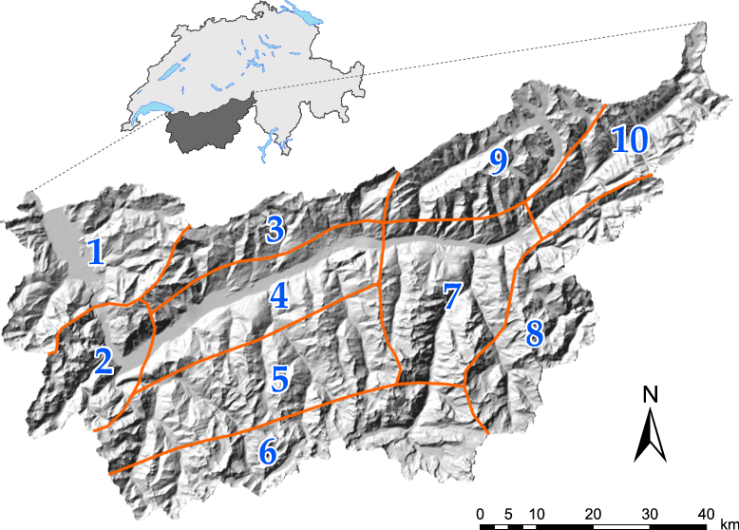

Figure 1: Location of the alpine Rhône catchment in Switzerland. (source: Swisstopo)

.5 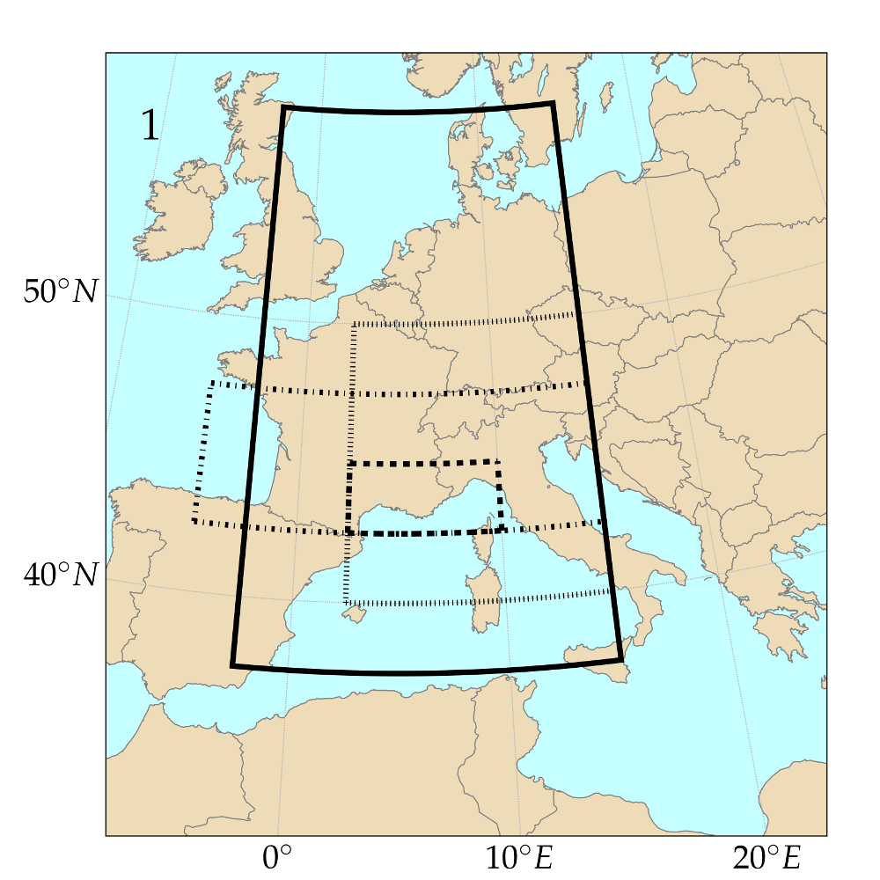 .5 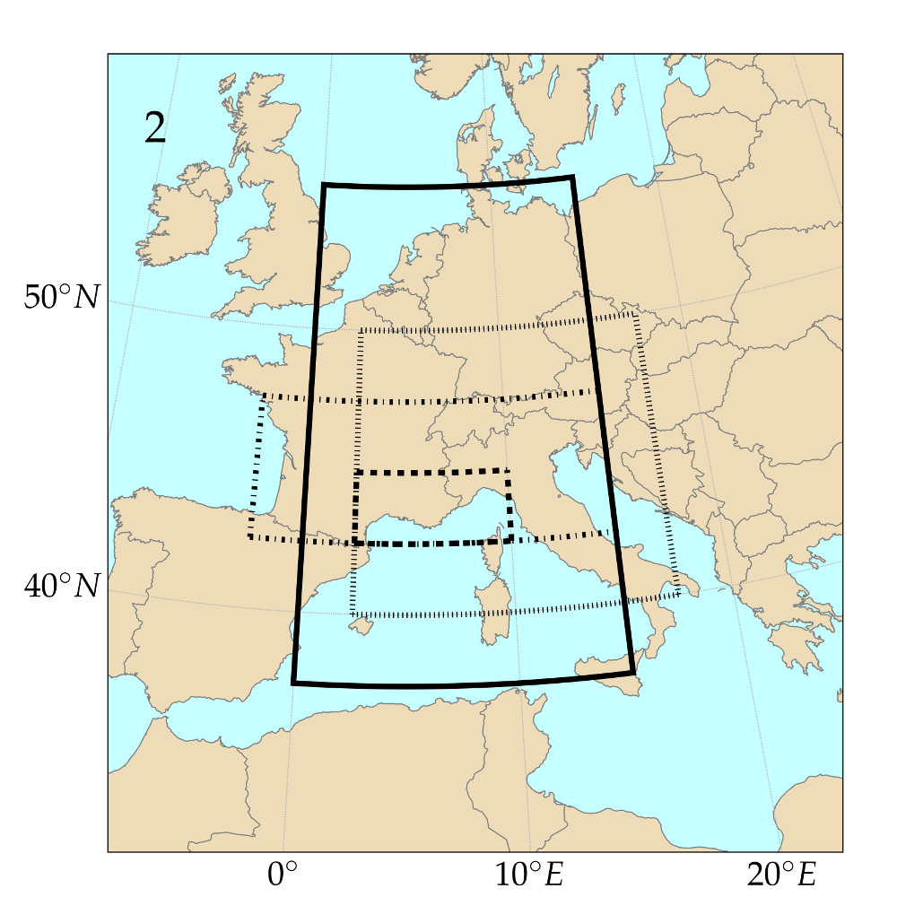 .5 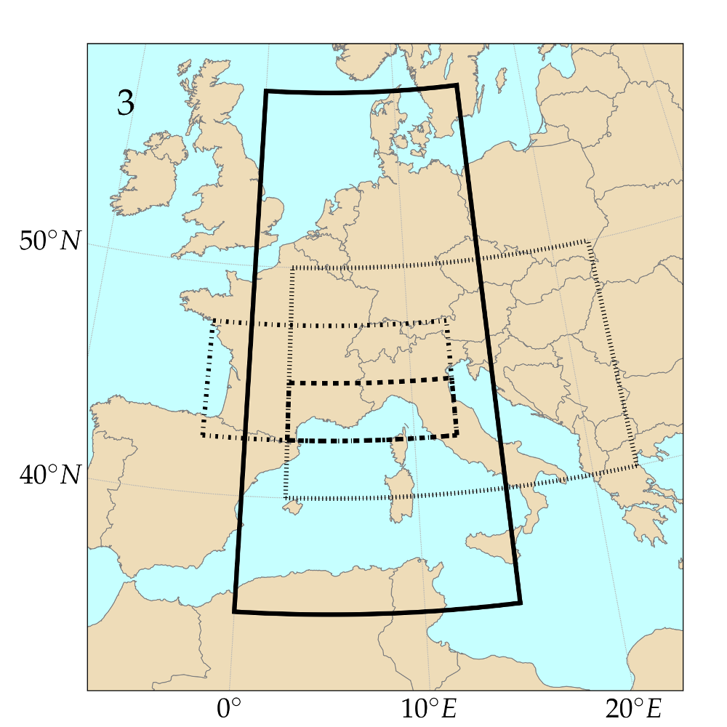 .5 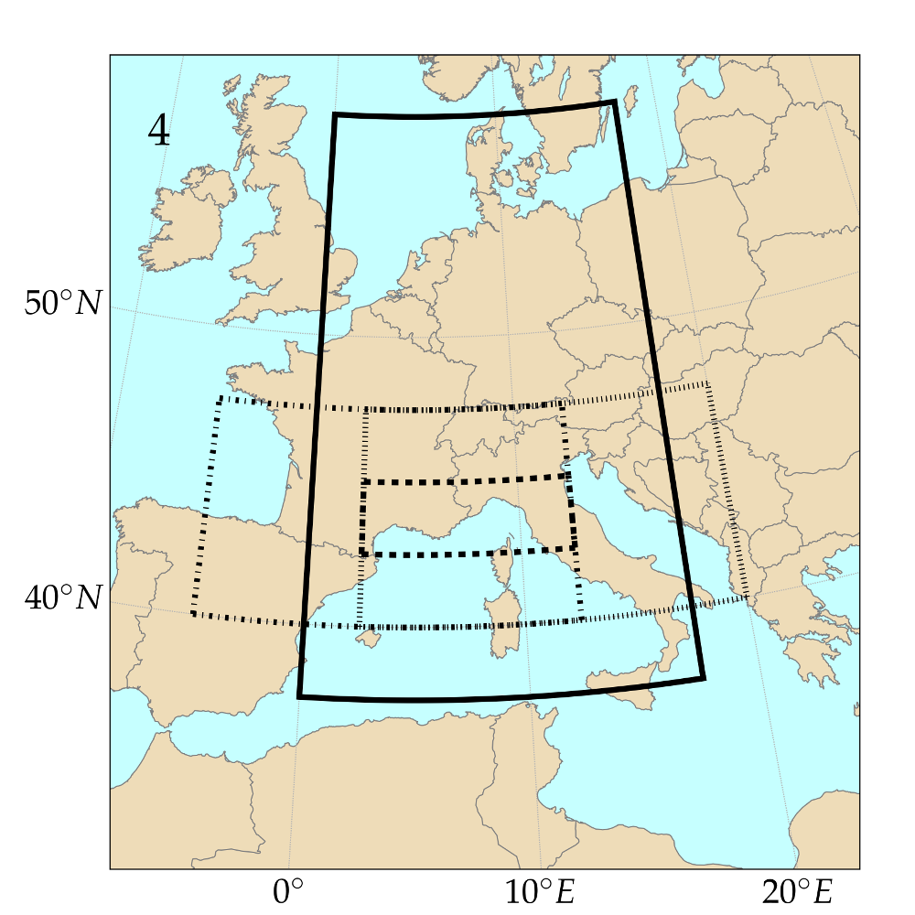 .5 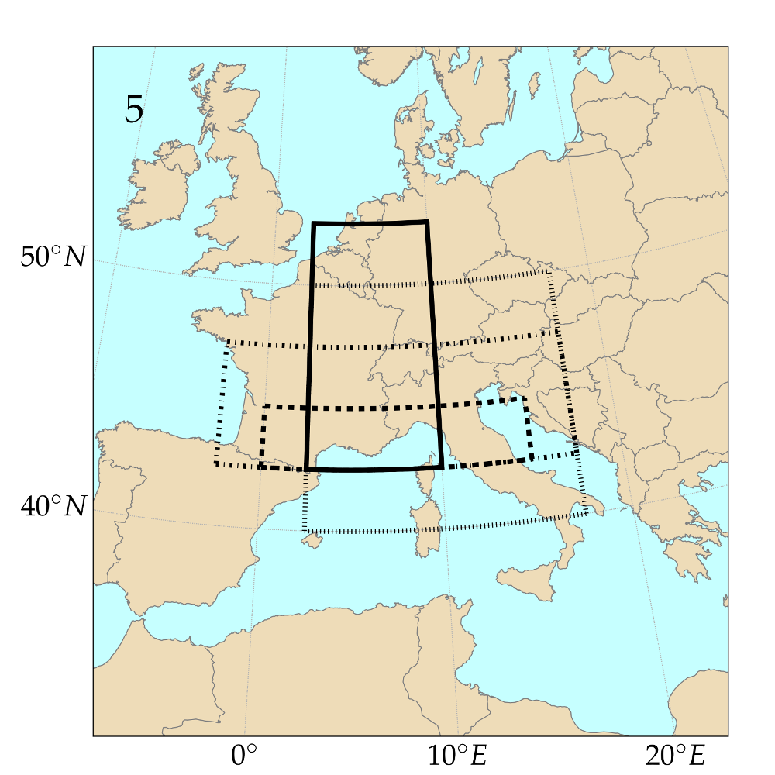 .5 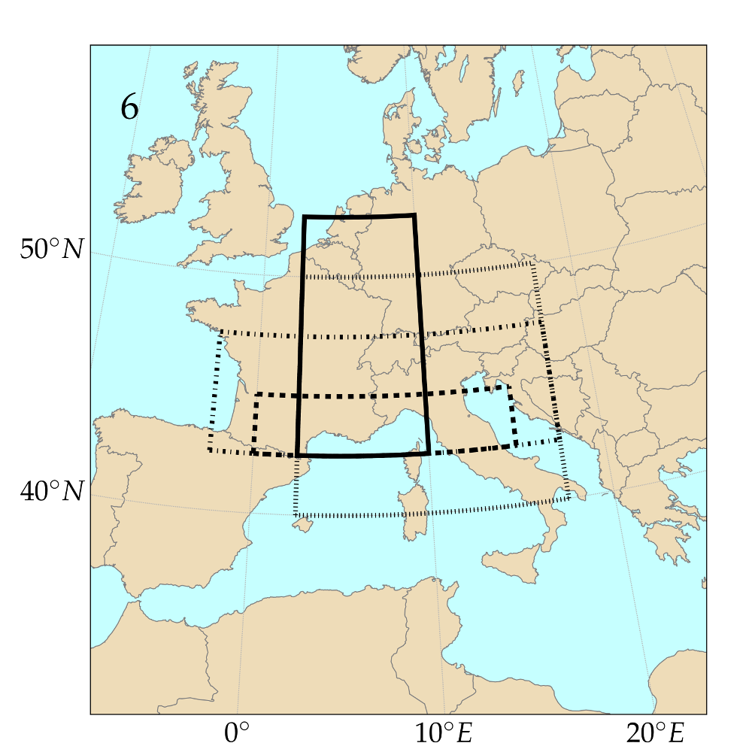 .5 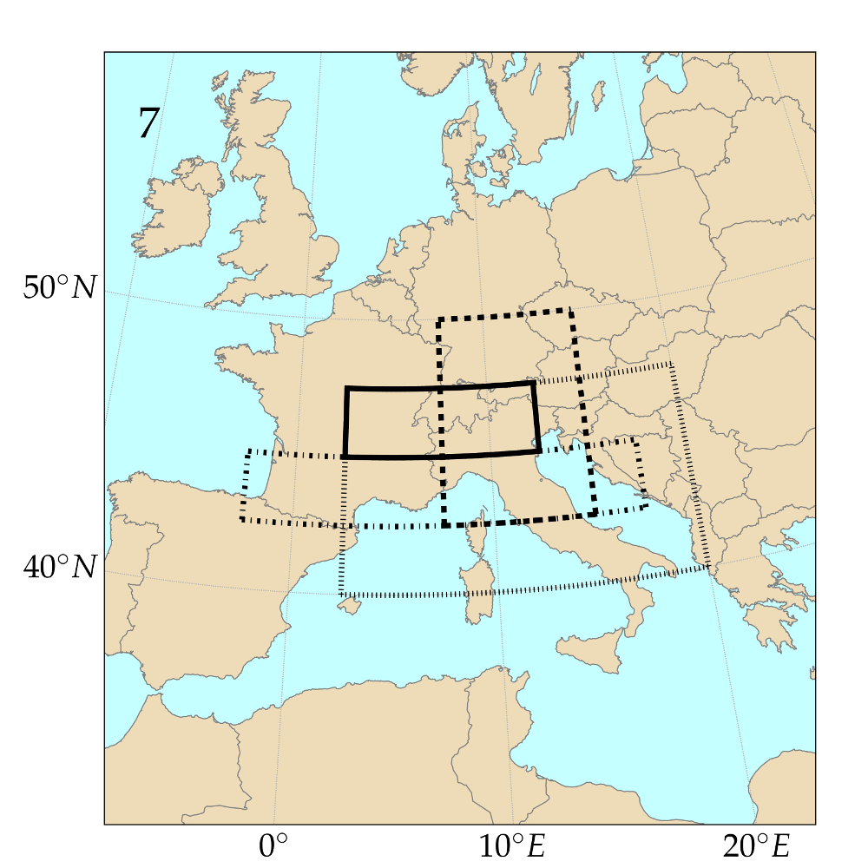 .5 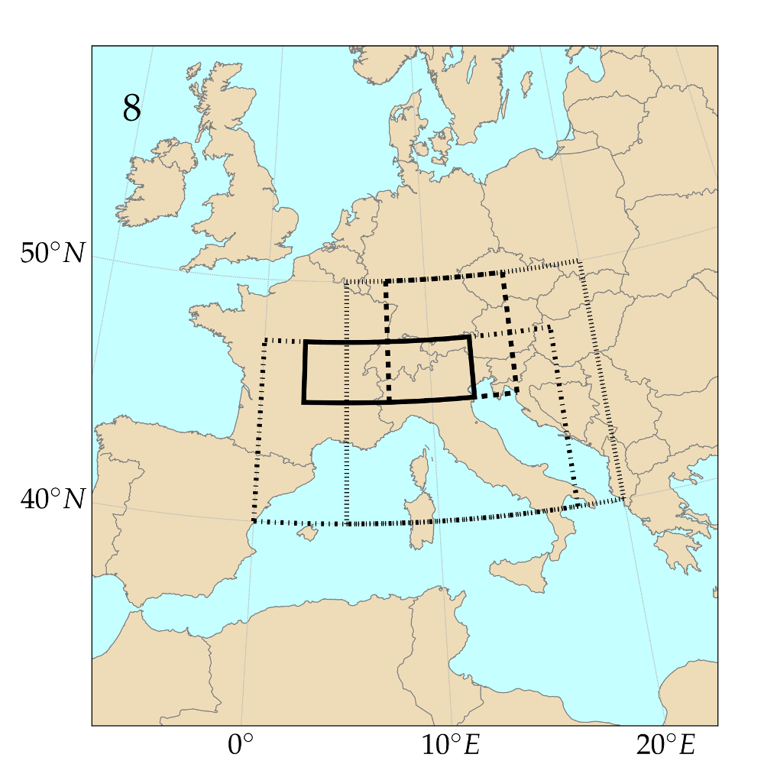 .5 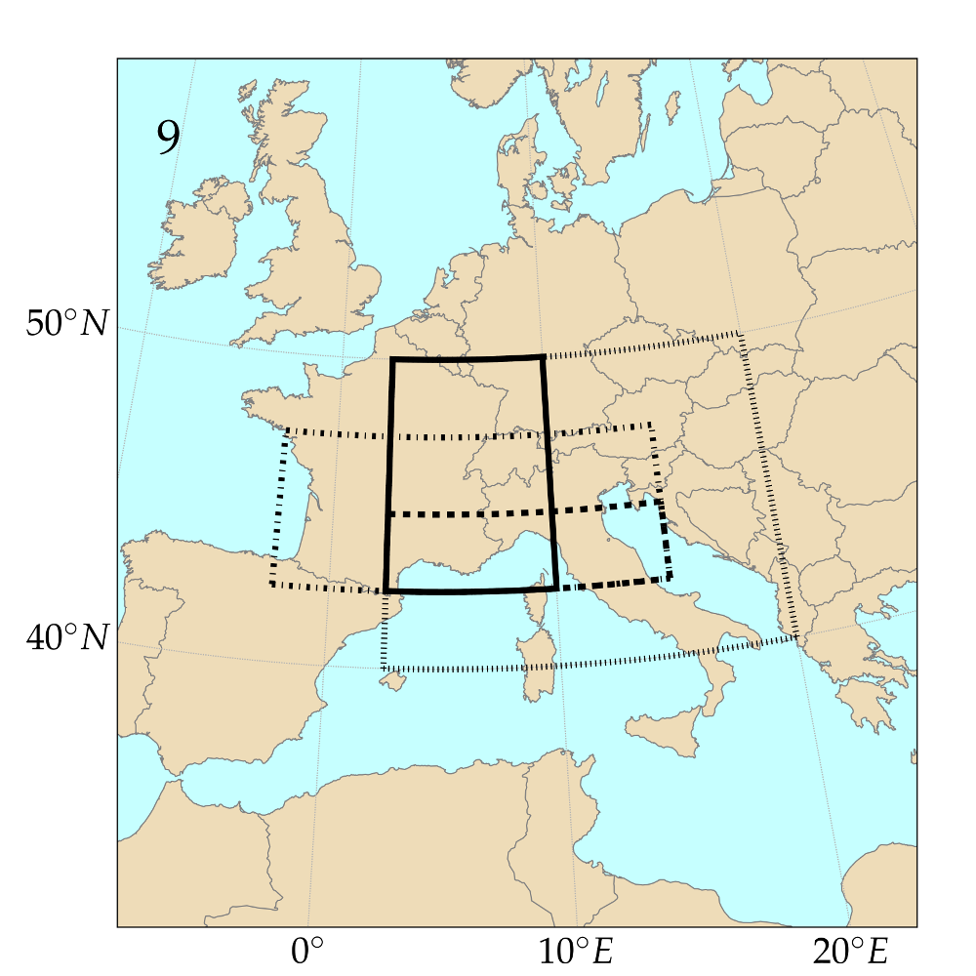 .5 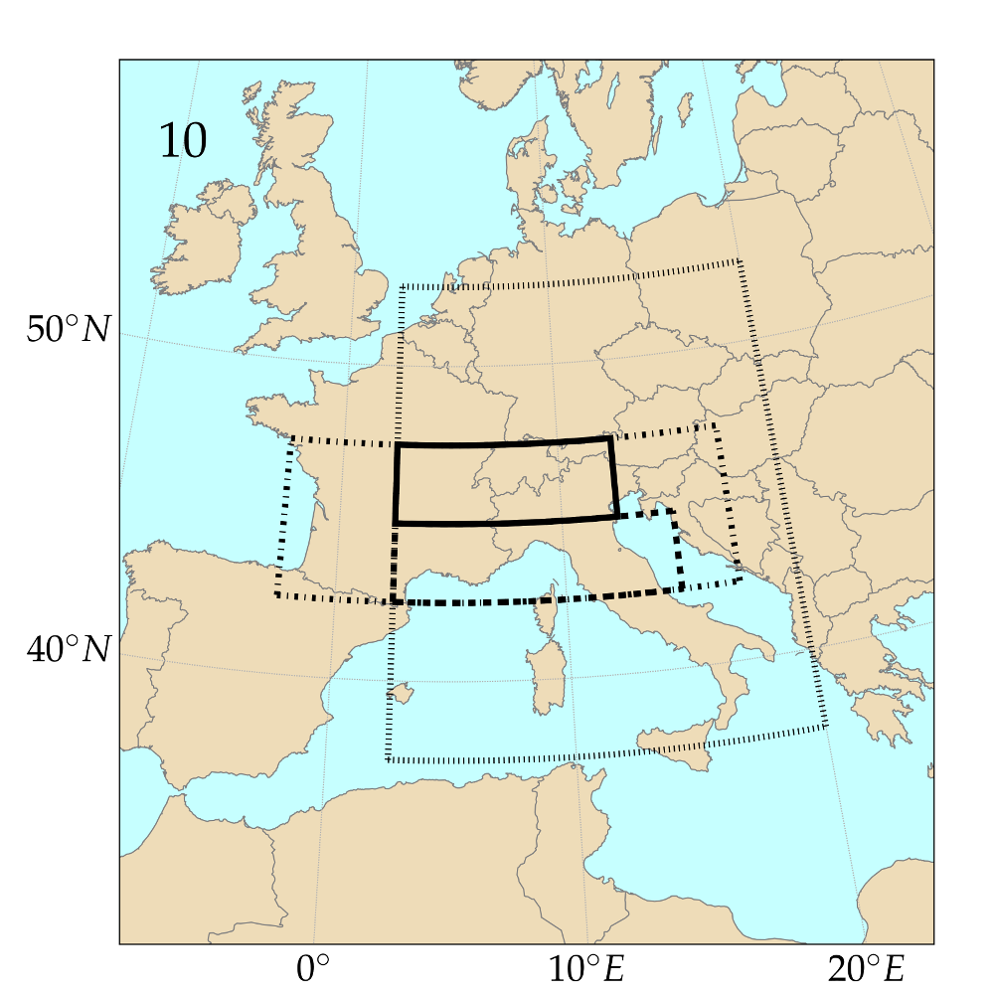 .5 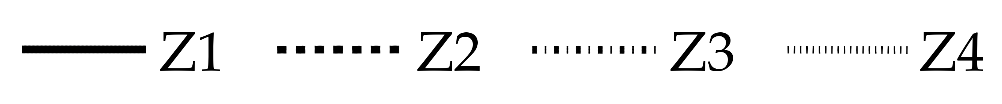

Figure 2: Optimized spatial windows for the 4Zo method (analogy of atmospheric circulation on 4 pressure levels). The pressure levels are ordered by increasing pressure and increasing time for the same levels.

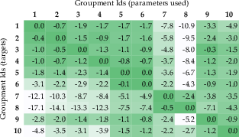

Figure 3: Losses or gains (in %) of the CRPSS by applying the optimized parameters for the series in column to those in line. Method 4Zo, calibration period.

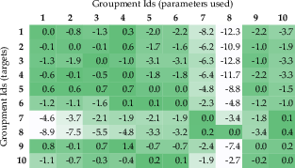

Figure 4: Same as Figure 3 but for the validation period.

.5 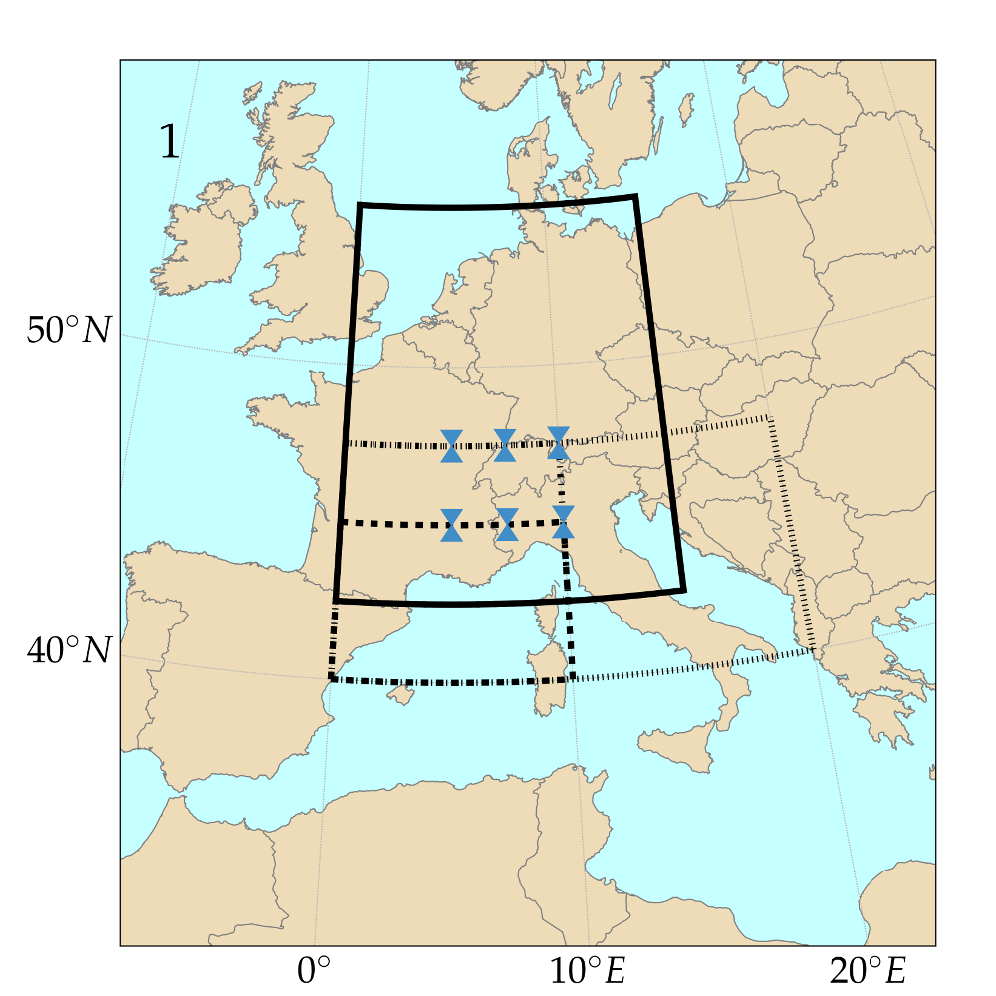 .5 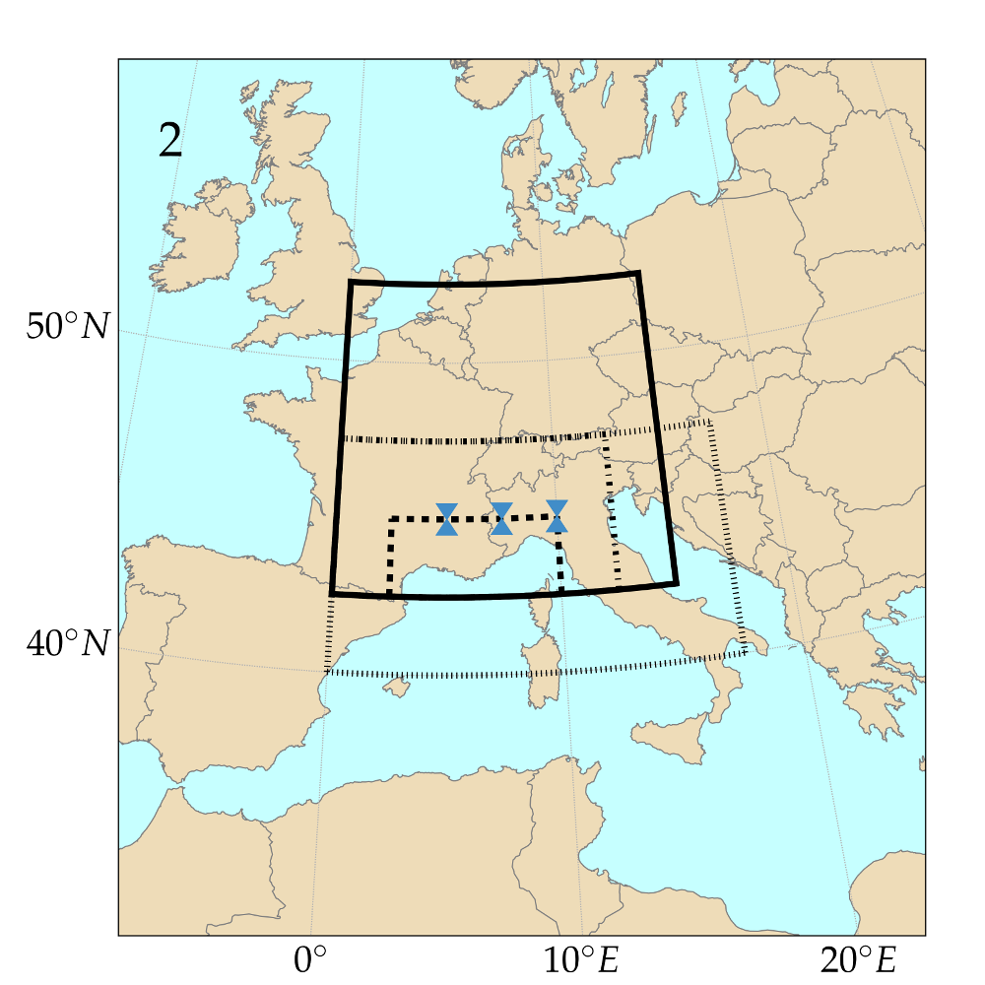 .5 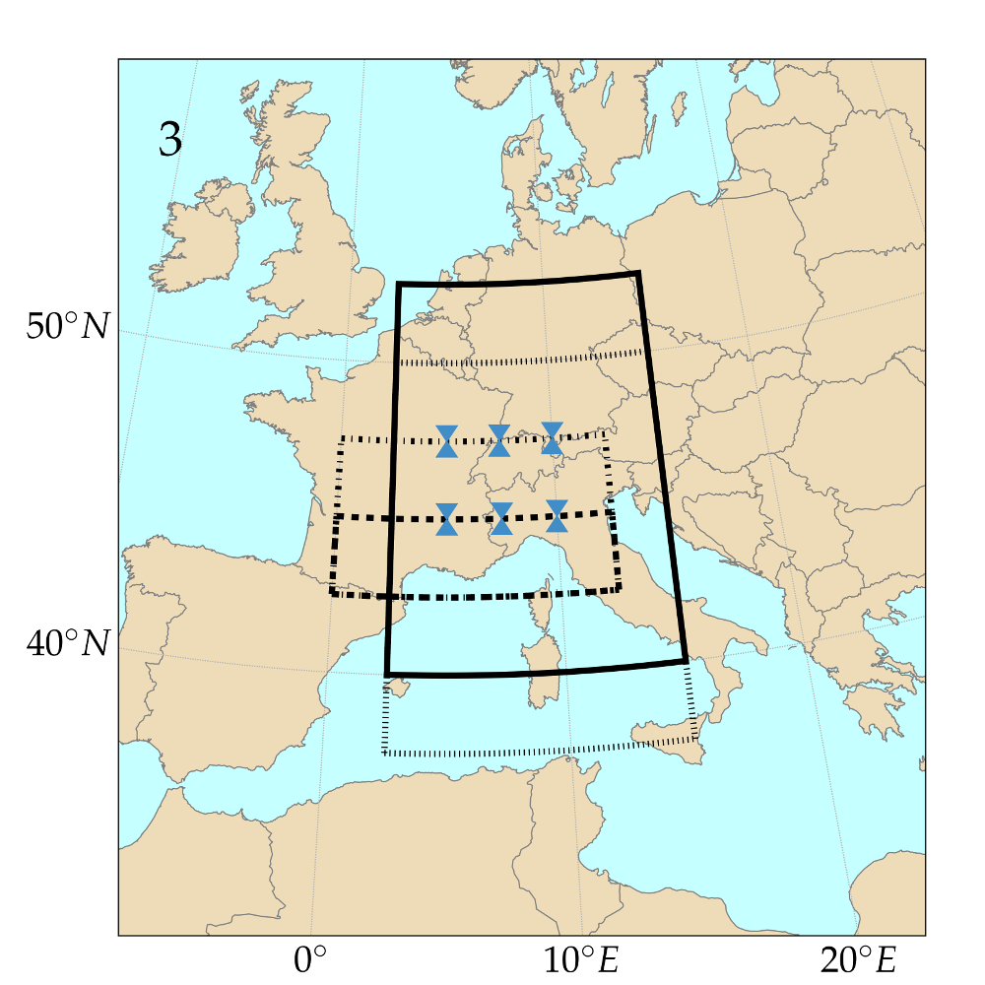 .5 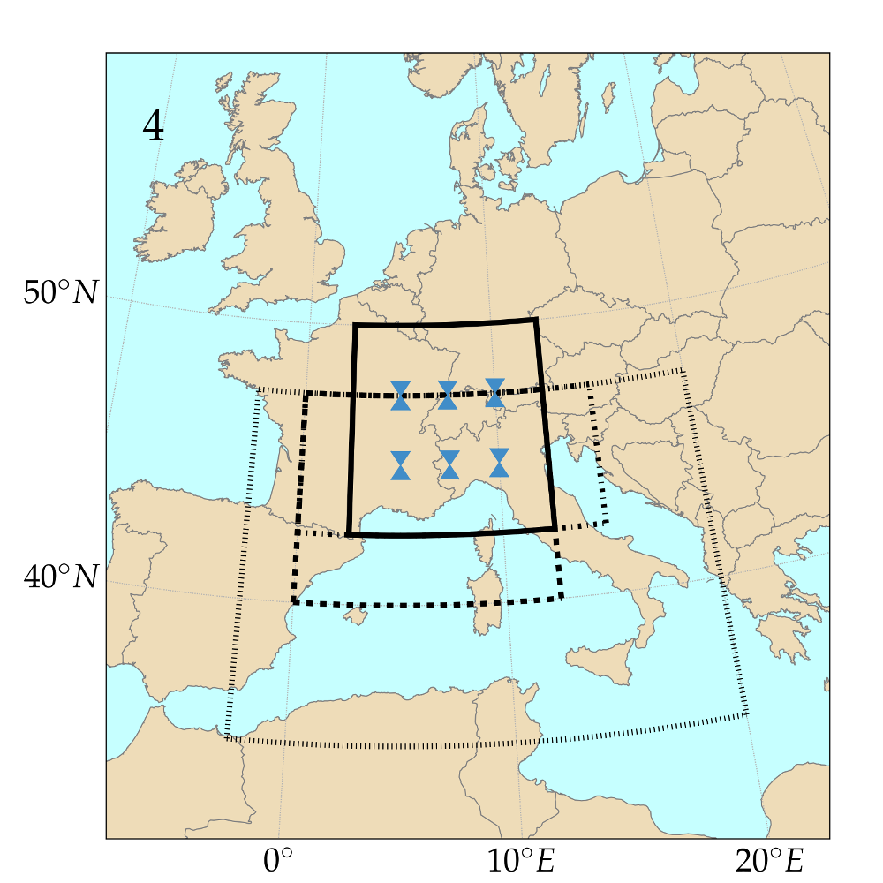 .5 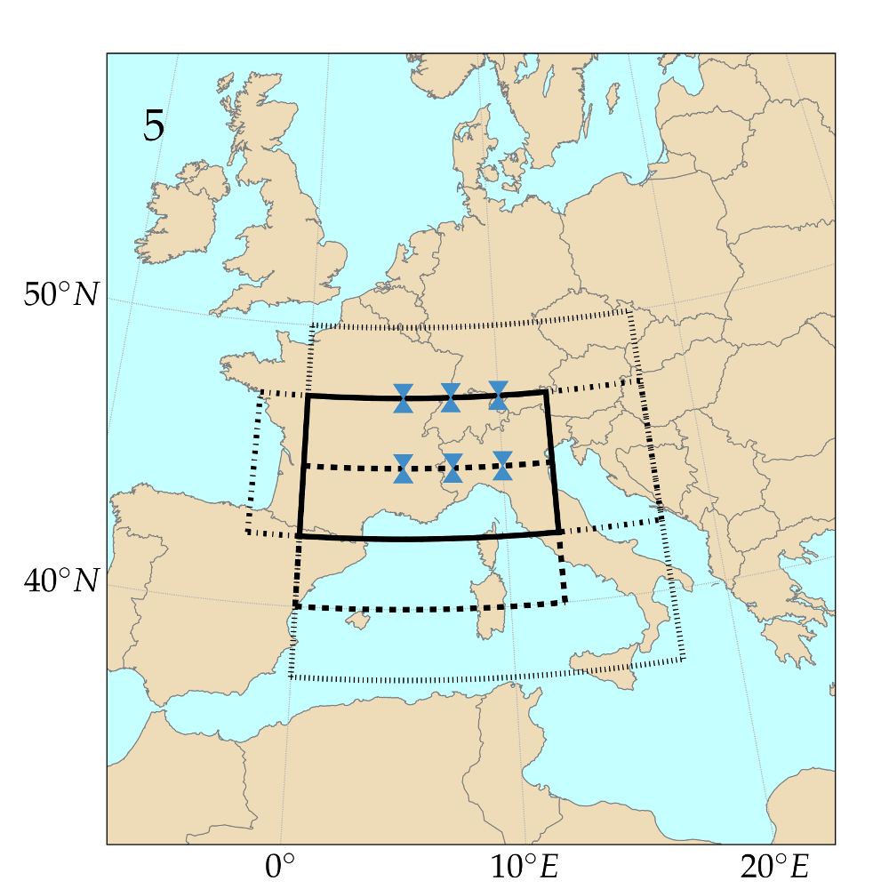 .5 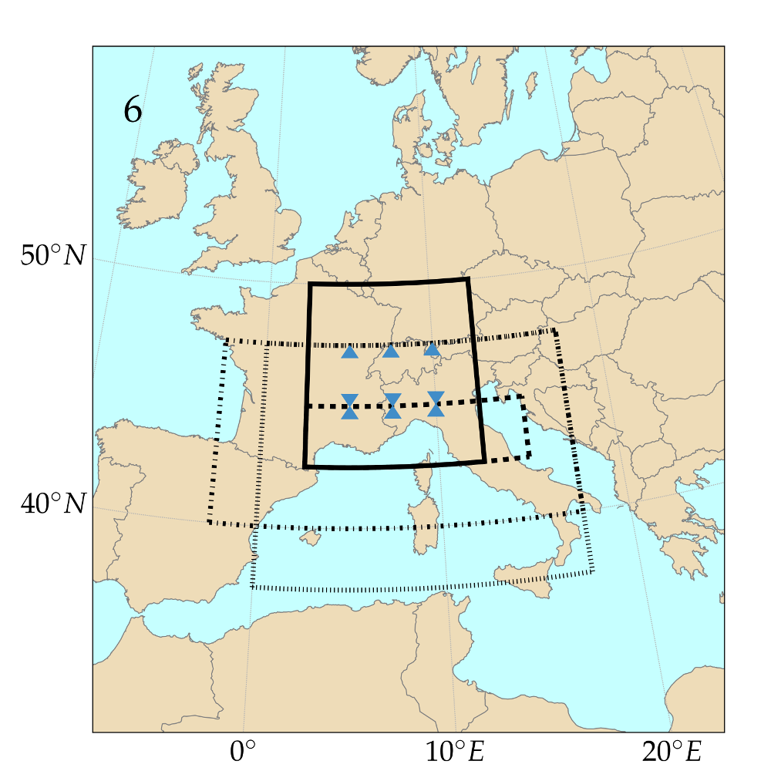 .5 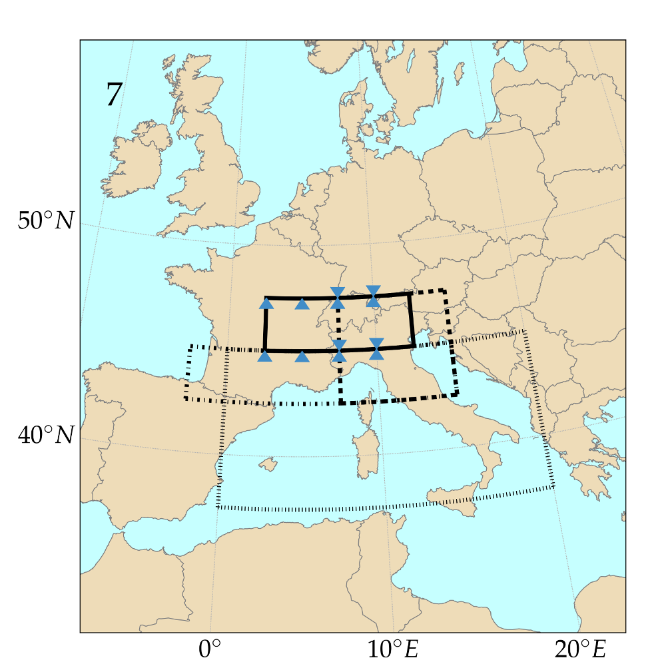 .5 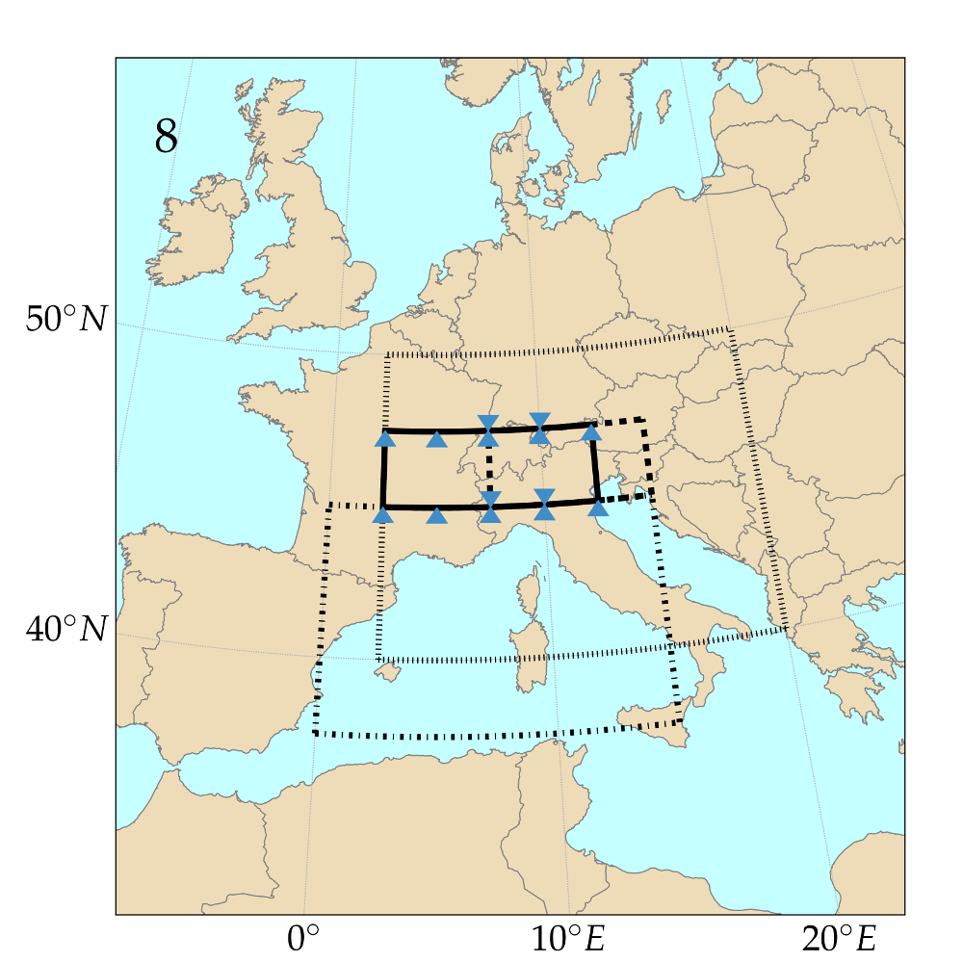 .5 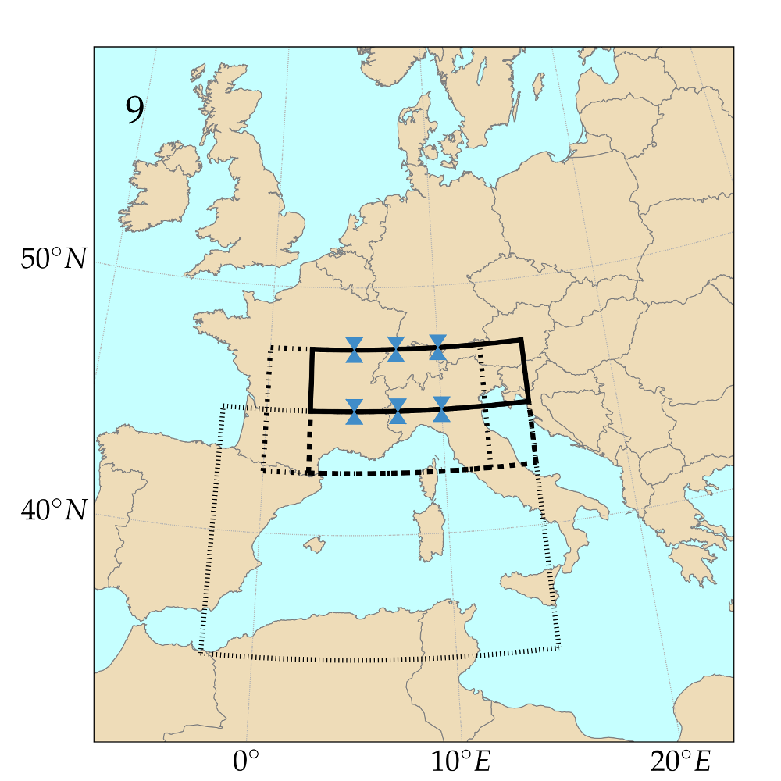 .5 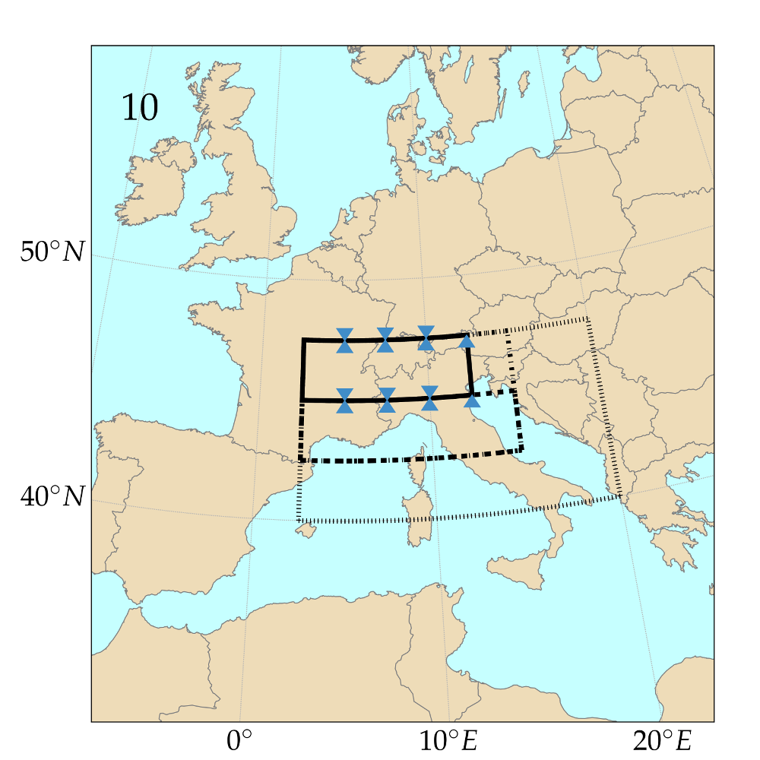 .5 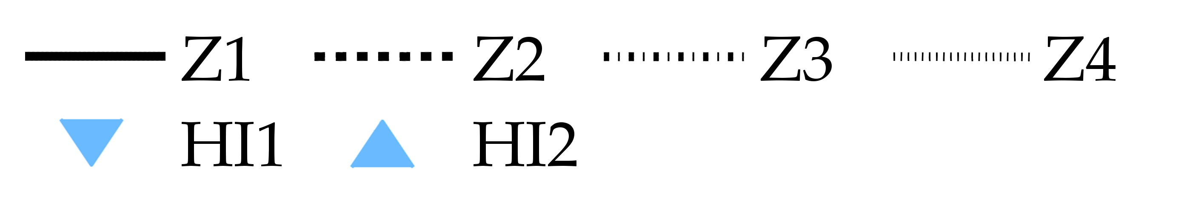

Figure 5: Optimized spatial windows for the 4Zo-2MIo method (analogy of atmospheric circulation on 4 pressure levels and the analogy on the moisture index on 2 pressure levels). The pressure levels are ordered by increasing pressure and increasing time for the same levels.

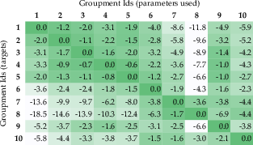

Figure 6: Losses or gains (in %) of the CRPSS by applying the optimized parameters for the series in column to those in line. Method 4Zo-2MIo, calibration period.

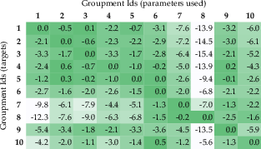

Figure 7: Same as Figure 6 but for the validation period.

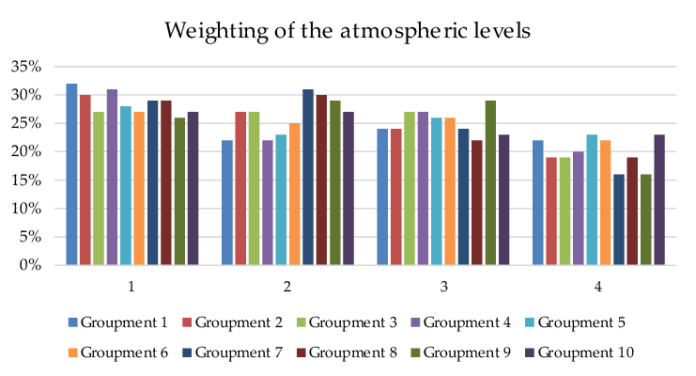

Figure 8: Optimized weighting for the pressure levels of the 4Zo method.

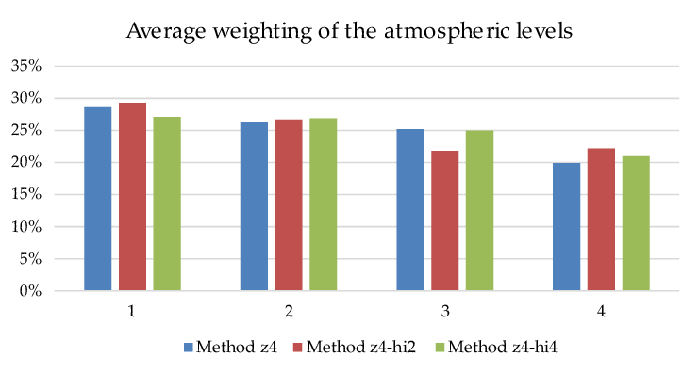

Figure 9: Averaged weighting for the pressure levels of the circulation analogy of the three methods.

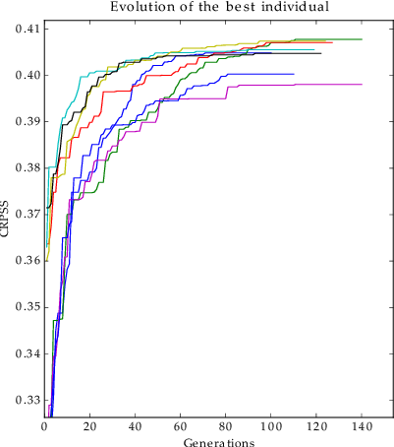

Figure 10: Example of the evolution of the performance score of the best individual over 8 independent optimizations.